KARNATAK LAW SOCIETY’S

GOGTE INSTITUTE OF TECHNOLOGY

UDYAMBAG, BELAGAVI-590008

(An Autonomous Institution under Visvesvaraya Technological University, Belagavi)

**(APPROVED BY AICTE, NEW DELHI)**

Department of Electronics and Communication Engineering



*Course Activity Report on*

**AIRLINE RESERVATION SYSTEM**

**in**

***C/C++***

***Submitted by***

*Hrushikesh Kitwadkar(2GI17EC039)*

*Abhay Kagwad(2GI17EC002)*

*Kaustubh Halyal(2GI17EC043)*

*Aditya Kulkarni(2GI17EC007)*

**Guide**

Prof. Uttam Deshpande

(Assistant Professor)

**2019-20**

**AIRLINE RESERVATION SYSTEM**

**Objective:**

To implement a convenient airline reservation system to manage the details of Airlines Ticket, Flights, Customer Booking.

**CODE:**

#include <stdio.h>

#include <stdlib.h>

#include <string.h>

void header()

{

printf("\n Flight Price Seating Capacity Available Seats\n");

printf("\n-----------------------------------------------------------------------------------\n");

}

void option1()

{

printf("\nFlightNo Flight Price Seating Capacity Available Seats\n");

printf("\n-----------------------------------------------------------------------------------\n");

printf(" 1 India To United states 1,500 100 16\n");

printf(" 2 India To China 1,000 75 0\n");

printf(" 3 India To Singapore 3,000 100 24\n");

}

void option2()

{

printf("\nnFlightNo Flight Price Seating Capacity Available Seats\n");

printf("\n-----------------------------------------------------------------------------------\n");

printf(" 1 India To United states 1,700 100 18\n");

printf(" 2 India To China 2,000 75 24\n");

printf(" 3 India To Singapore 4,000 100 65\n");

}

void option3()

{

printf("\n.nFlightNo Flight Price Seating Capacity Available Seats\n");

printf("\n-----------------------------------------------------------------------------------\n");

printf(" 1 India To United states 2,000 100 46\n");

printf(" 2 India To China 1,500 75 16\n");

printf(" 3 India To Singapore 4,000 100 85\n");

}

int choice()

{

}

struct flight{

int ticket;

int price;

};

//Initialization of variables

struct flight book[10];

int fare[3][10]={{1500,1000,3000},{1700,2000,4000},{2000,1500,4000}};

int amount=0;

int rfare=0;

int main() {

//Setting Username=GIT and Password=root

char user[50], pw[50], adminu[50]="GIT", adminpw[50]="root";

int trip, date, date2, a, x, y;

float total;

char repeat;

int amount=0;

printf("\nEnter username: ");

scanf("%s", &user);

printf("\nEnter password: ");

scanf("%s", &pw);

if (strcmp(user, adminu)==0 && strcmp(pw, adminpw)==0)

{

printf("\nWelcome");

printf("\nChoose if one way trip or roundtrip: "); // Choosing One way or Round Trip.

printf("\n1. One way trip \n2. Roundtrip\n");

scanf("\n%d", &trip);

printf("\nDate: ");

printf("\n1. November 23, 2019 \n2. November 24, 2019\n3. November 25, 2019(not applicable for round trip)\n");

scanf("%d", &date);

//Selection of three different dates and depending on it choosing the flights.One Way Trip

switch (trip)

{

case 1:

{

if (date==1)

{

printf("\nNovember 23, 2019\n");

option1();

printf("\nHow many tickets will you get?:");

scanf("%d", &x);

for (a=1; a<=x; a++)

{

printf("\nPlease select which flight you will book: ");

scanf("%d", &book[a].ticket);

amount=amount+fare[date-1][book[a].ticket-1];

}

}

else if (date==2)

{

printf("\nNovember 24, 2019\n");

option2();

printf("\nHow many tickets will you get?: ");

scanf("%d", &x);

for (a=1; a<=x; a++)

{

printf("\nPlease select which flight you will book: ");

scanf("%d", &book[a].ticket);

amount=amount+fare[date-1][book[a].ticket-1];

}

}

else if (date==3)

{

printf("\nANovember 25, 2019\n");

option3();

printf("\nHow many tickets will you get?: ");

scanf("%d", &x);

for (a=1; a<=x; a++)

{

printf("\nPlease select which flight you will book: ");

scanf("%d", &book[a].ticket);

amount=amount+fare[date-1][book[a].ticket-1];

}

}

else printf("\nInvalid");

break;

}

//Round Trip implementation using case statement

case 2:

{

if (date==1)

{

printf("\nNovember 23, 2019\n");

option1();

printf("\nChoose date of return: \n1. November 24, 2019\n2. November 25, 2019\n");

scanf("%d", &date2);

printf("\nHow many tickets will you get (excluding the return trip)?: ");

scanf("%d", &x);

printf("\nTickets for return trip: %d",x);

for (a=1; a<=x; a++)

{

printf("\nPlease select which flight you will book: ");

scanf("%d", &book[a].ticket);

amount=amount+fare[date-1][book[a].ticket-1];

if (date2==1)

{

switch (book[a].ticket)

{

case 1:

{

printf("\nDetails for return trip");

header();

printf(" United States to India 1,700 100 \t45\n");

rfare=rfare+fare[date][book[a].ticket-1];

break;

}

case 2:

{

printf("\nDetails for return trip");

header();

printf(" China to India 2,000 75 \t67\n");

rfare=rfare+fare[date][book[a].ticket-1];

break;

}

case 3:

{

printf("\nDetails for return trip");

header();

printf(" Singapore to India 4,000 100 \t46\n");

rfare=rfare+fare[date][book[a].ticket-1];

break;

}

default: break;

}

}

else if (date2==2)

{

switch (book[a].ticket)

{

case 1:

{

header();

printf(" United States to India 2,000 100 \t45");

rfare=rfare+fare[date][book[a].ticket-1];

break;

}

case 2:

{

header();

printf(" China to India 1,500 75 \t67");

rfare=rfare+fare[date][book[a].ticket-1];

break;

}

case 3:

{

header();

printf(" Singapore to India 4,000 100 \t46");

rfare=rfare+fare[date][book[a].ticket-1];

break;

}

default: break;

}

}

else

{

printf("\nInvalid");

return 0;

}

}

}

else if (date==2)

{

printf("\nNovember 24, 2019\n");

option2();

printf("\nHow many tickets will you get?: ");

scanf("%d", &x);

for (a=1; a<=x; a++)

{

printf("\nPlease select which flight you will book: ");

scanf("%d", &book[a].ticket);

amount=amount+fare[date-1][book[a].ticket-1];

}

}

else if (date==3)

{

printf("\nNovember 25, 2019\n");

option3();

printf("\nHow many tickets will you get?: ");

scanf("%d", &x);

for (a=1; a<=x; a++)

{

printf("\nPlease select which flight you will book: ");

scanf("%d", &book[a].ticket);

amount=amount+fare[date-1][book[a].ticket-1];

}

}

else printf("\nInvalid");

break;

break;

}

default:

break;

}

printf("\n");

//Total Bill

printf("\nSummary: ");

for (a=1; a<=x; a++)

{

printf("\nDetails of Ticket no. [%d]", a);

printf("\nFlight no. [%d]\n", book[a].ticket);

}

total=book[a].price;

printf("\nTotal number of tickets: %d\n", x);

printf("\nTotal Price for one way trip: %d",amount);

printf("\nTotal Price for return trip: %d\n",rfare);

printf("\nThank you for booking..........Have a safe journey.\n");

}

else

{

printf("\nInvalid login\n");

}

return 0;

}

**INPUT/OUTPUT:**

**Sample Input/output 1:**

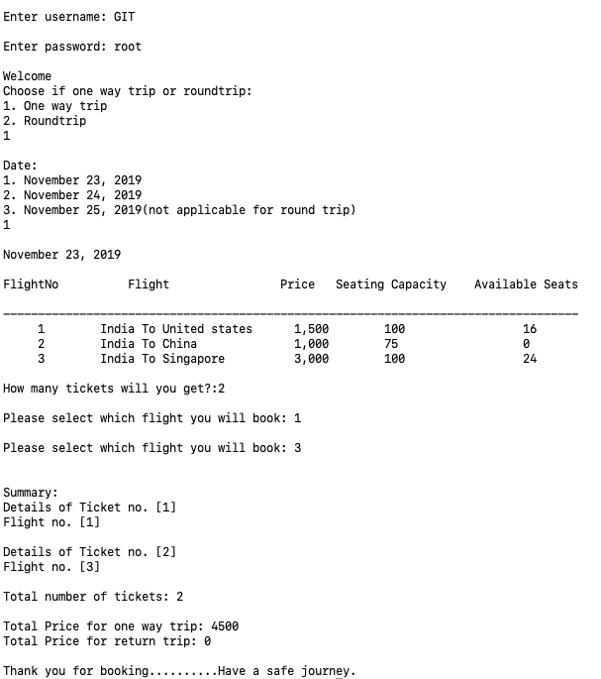

**Sample Input/output 2:**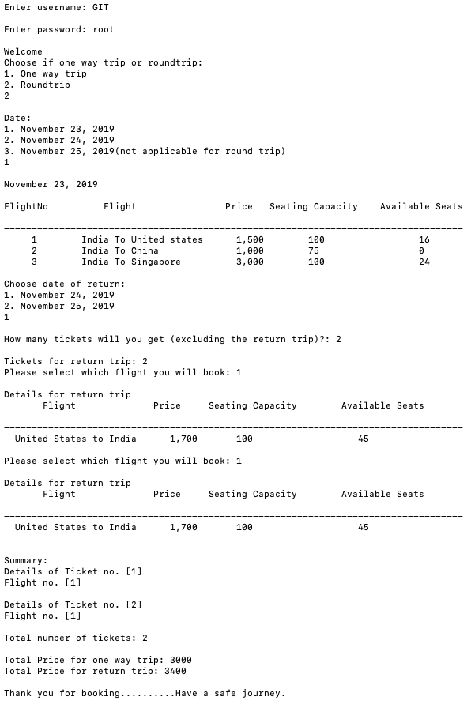

**Sample Input/output 3:**

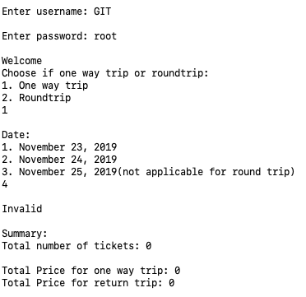

**Sample Input/output 4:**

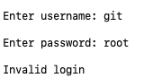

**Limitations:**

1) Round trip option is applicable only for date1.

2) Can't book a specific seat. The system itself allots the seat.

**Improvements:**

1) Could store the customer information in a database.

2) Could add some more code to book a Cab/Hotel etc while booking the flight.

3) Could be improved to add a feature of selecting travel class(Economy/Business).